 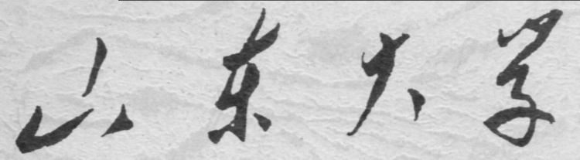

**崇新学堂**

**2022－2023学年第一学期**

实 验 报 告

课程名称： Experiments of Introduction to EECS

实验名称： A Real Head-Turner

专 业 班 级 崇新21

学 生 姓 名 余昊 葛明烨 崔宇鑫

实 验 时 间 2022年11月23日

**Step1**

We connect the following circuits according to the circuit diagram in homework3.

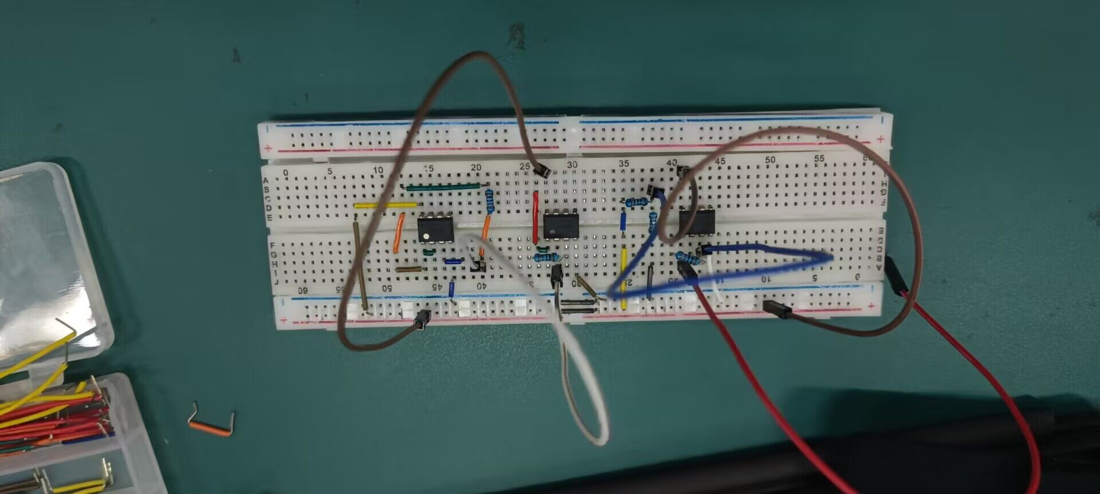

Change the gain by changing the resistance value of the resistor at the output of the sensor.

**Step2**

**SL9测量结果：**

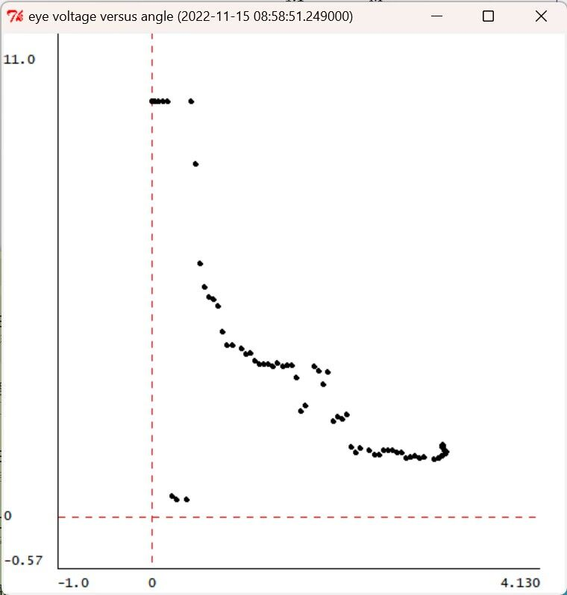

*neck= 0.127077223851 left= 10.0 right= 10.0  
neck= 0.127077223851 left= 10.0 right= 10.0  
neck= 0.127077223851 left= 10.0 right= 10.0  
neck= 0.127077223851 left= 10.0 right= 10.0  
neck= 0.136852394917 left= 10.0 right= 10.0  
neck= 0.136852394917 left= 10.0 right= 10.0  
neck= 0.127077223851 left= 0.49853372434 right= 10.0  
neck= 0.127077223851 left= 0.439882697947 right= 10.0  
neck= 0.127077223851 left= 0.420332355816 right= 10.0  
neck= 0.127077223851 left= 10.0 right= 10.0  
neck= 0.127077223851 left= 8.48484848485 right= 10.0  
neck= 0.127077223851 left= 6.10948191593 right= 10.0  
neck= 0.127077223851 left= 5.54252199413 right= 10.0  
neck= 0.136852394917 left= 5.28836754643 right= 10.0  
neck= 0.136852394917 left= 5.2394916911 right= 10.0  
neck= 0.127077223851 left= 5.07331378299 right= 10.0  
neck= 0.127077223851 left= 4.45747800587 right= 10.0  
neck= 0.127077223851 left= 4.1348973607 right= 10.0  
neck= 0.127077223851 left= 4.12512218964 right= 10.0  
neck= 0.127077223851 left= 4.05669599218 right= 10.0  
neck= 0.127077223851 left= 3.92961876833 right= 10.0  
neck= 0.127077223851 left= 3.95894428152 right= 10.0  
neck= 0.127077223851 left= 3.76344086022 right= 10.0  
neck= 0.136852394917 left= 3.68523949169 right= 10.0  
neck= 0.136852394917 left= 3.68523949169 right= 10.0  
neck= 0.127077223851 left= 3.67546432063 right= 10.0  
neck= 0.127077223851 left= 3.6265884653 right= 10.0  
neck= 0.136852394917 left= 3.69501466276 right= 10.0  
neck= 0.127077223851 left= 3.61681329423 right= 10.0  
neck= 0.127077223851 left= 3.64613880743 right= 10.0  
neck= 0.127077223851 left= 3.65591397849 right= 10.0  
neck= 0.127077223851 left= 3.35288367546 right= 10.0  
neck= 0.127077223851 left= 2.55131964809 right= 10.0  
neck= 0.127077223851 left= 2.69794721408 right= 10.0  
neck= 0.127077223851 left= 3.61681329423 right= 10.0  
neck= 0.127077223851 left= 3.51906158358 right= 10.0  
neck= 0.127077223851 left= 3.18670576735 right= 10.0  
neck= 0.127077223851 left= 3.49951124145 right= 10.0  
neck= 0.127077223851 left= 2.29716520039 right= 10.0  
neck= 0.127077223851 left= 2.41446725318 right= 10.0  
neck= 0.127077223851 left= 2.36559139785 right= 10.0  
neck= 0.127077223851 left= 2.47311827957 right= 10.0  
neck= 0.127077223851 left= 1.69110459433 right= 10.0  
neck= 0.127077223851 left= 1.56402737048 right= 10.0  
neck= 0.127077223851 left= 1.66177908113 right= 10.0  
neck= 0.127077223851 left= 1.60312805474 right= 10.0  
neck= 0.127077223851 left= 1.49560117302 right= 10.0  
neck= 0.127077223851 left= 1.51515151515 right= 10.0  
neck= 0.127077223851 left= 1.61290322581 right= 10.0  
neck= 0.136852394917 left= 1.61290322581 right= 10.0  
neck= 0.127077223851 left= 1.62267839687 right= 10.0  
neck= 0.127077223851 left= 1.54447702835 right= 10.0  
neck= 0.127077223851 left= 1.54447702835 right= 10.0  
neck= 0.127077223851 left= 1.4173998045 right= 10.0  
neck= 0.127077223851 left= 1.45650048876 right= 10.0  
neck= 0.127077223851 left= 1.48582600196 right= 10.0  
neck= 0.127077223851 left= 1.42717497556 right= 10.0  
neck= 0.127077223851 left= 1.44672531769 right= 10.0  
neck= 0.127077223851 left= 1.39784946237 right= 10.0  
neck= 0.127077223851 left= 1.4173998045 right= 10.0  
neck= 0.127077223851 left= 1.48582600196 right= 10.0  
neck= 0.127077223851 left= 1.52492668622 right= 10.0  
neck= 0.127077223851 left= 1.57380254154 right= 10.0  
neck= 0.127077223851 left= 1.58357771261 right= 10.0  
neck= 0.127077223851 left= 1.60312805474 right= 10.0  
neck= 0.127077223851 left= 1.60312805474 right= 10.0  
neck= 0.127077223851 left= 1.69110459433 right= 10.0  
neck= 0.127077223851 left= 1.74975562072 right= 10.0  
neck= 0.127077223851 left= 1.69110459433 right= 10.0  
neck= 0.127077223851 left= 1.73020527859 right= 10.0  
neck= 0.127077223851 left= 1.75953079179 right= 10.0  
Starting to rotate 3.09159265359*

In softwarelab9, we find that the v_s signal as a function of rotation angle generated by soar is not ideal, and even tends to a straight line. So we use the best gain in homework3 for the experiment. According to homework3, we can calculate the best k_c = 2.1. But in the actual experiment, we use k_s=2, which has the same good convergence effect.

We connected the circuit to the head according to the infrastructure guidelines and set up a strong light source near the head to turn it. We found that when we moved the light source, the head moved with the light source. Under the condition that the gain k_c is 2, the trolley can be rotated to the location of the light source at the optimal convergence rate.

**Step3 ＆ Step4**

When we used the only intact potentiometer connector sensor, we found that when the potentiometer can perform unlimited rotation. This will lead to very strange voltage measurements.

We try to study the output voltage of potentiometer without rotating the potentiometer. In theory, the output voltage should be a constant value, but in practice, the output voltage value is shown in the figure below.

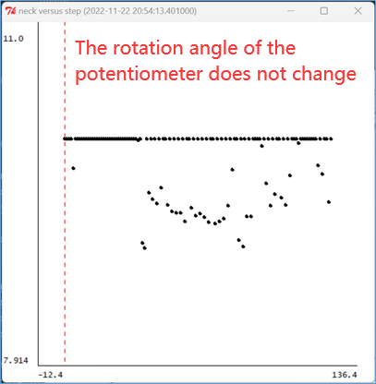

This is a very strange figure. Because even if we turn the Angle of the potentiometer, the output voltage of the potentiometer seems to be 10V without the connection of the head sensor. This is contrary to the theoretical value. In theory, when we turn the potentiometer and leave it unchanged, the potentiometer should output a different voltage stabilizer. The Angle alpha of the potentiometer should be proportional to the output voltage, but it is not.

We tried to fix the position of the light source, and we tried to connect the motor on the head sensor to the potentiometer. When k_c=2, the result obtained was shown in the figure below. 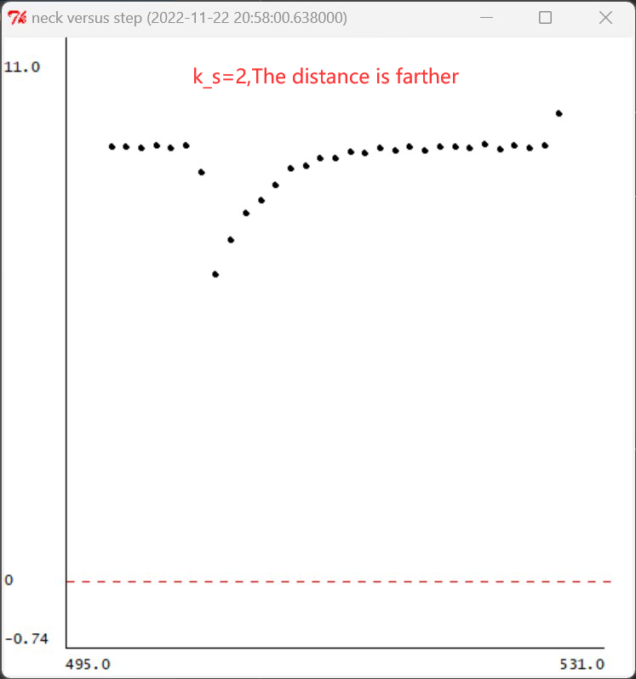

We found that when the motor of the head drives the potentiometer to rotate, the output voltage of the potentiometer always starts from a certain voltage value and finally tends to 10V. Theoretically, the output voltage of the potentiometer should indeed start from a certain voltage value and end at a certain voltage value, but it should not always be 10V. As we mentioned in the previous paragraph, when the potentiometer does not rotate, the output voltage is constant 10V, so we only pay attention to the change of the rising part of the output voltage of the potentiometer, not the voltage value when the output voltage is stable.

When we continue the experiment by changing the resistance increase k_c we get the following results. At this point, k_c equals 4.

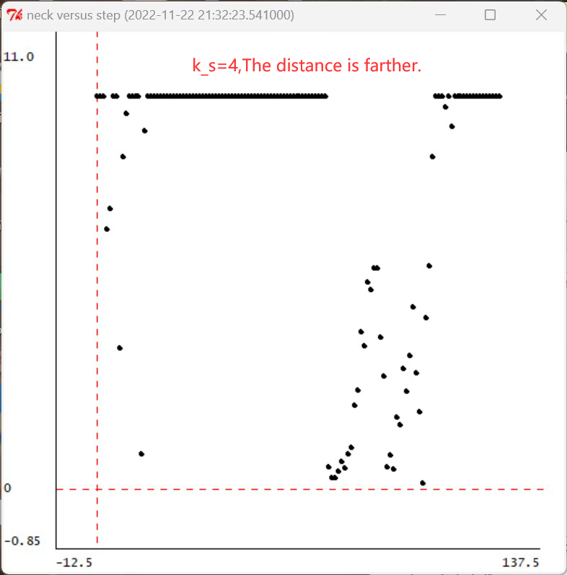

We found that the potentiometer output voltage changes significantly more than when k_c equals 2. This is because the increase in the k_s increases the speed of the motor.

We decrease the distance of the light source and adjust k_s=2 to get the following output.

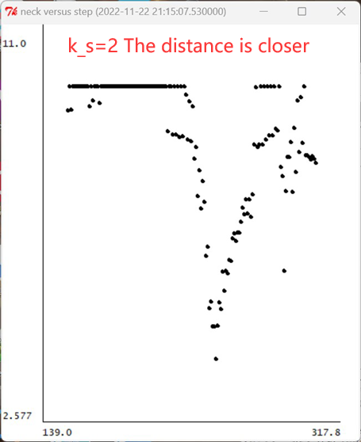

We found that the potentiometer output voltage changed to 10V faster than before the distance decreased.

We decrease the distance of the light source and adjust k_s=4 to get the following output.

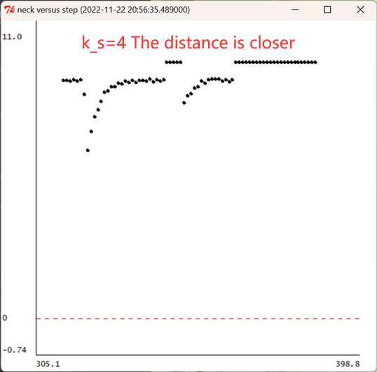

We found that the potentiometer output voltage oscillates around 10V. This is because the motor speed is too fast due to large k_s, which produces small oscillations near the light source and cannot converge quickly and directly.

**Summary**

1. During the experiment, we observed that the quiescent voltage of the potentiometer was always 10V. It is better to ignore the value of the output voltage at this time, use the voltage output of 10V at stable time as the steady state of the potentiometer at rest, and observe the change trend of the output voltage.

2. When the potentiometer starts to rotate, the initial value of the output voltage of the potentiometer will always change to a certain small value and gradually rise. This is consistent with the result in 1. When the potentiometer starts to rotate, the steady state of the output voltage of 10V will be broken, and the measured voltage will be the real voltage, and the output voltage will gradually increase as the angle increases.

3. 从理论上来说，当电位器从α=1开始，顺时针旋转时，我们想要得到的电压随采样点的变化趋势应该如下图所示：

